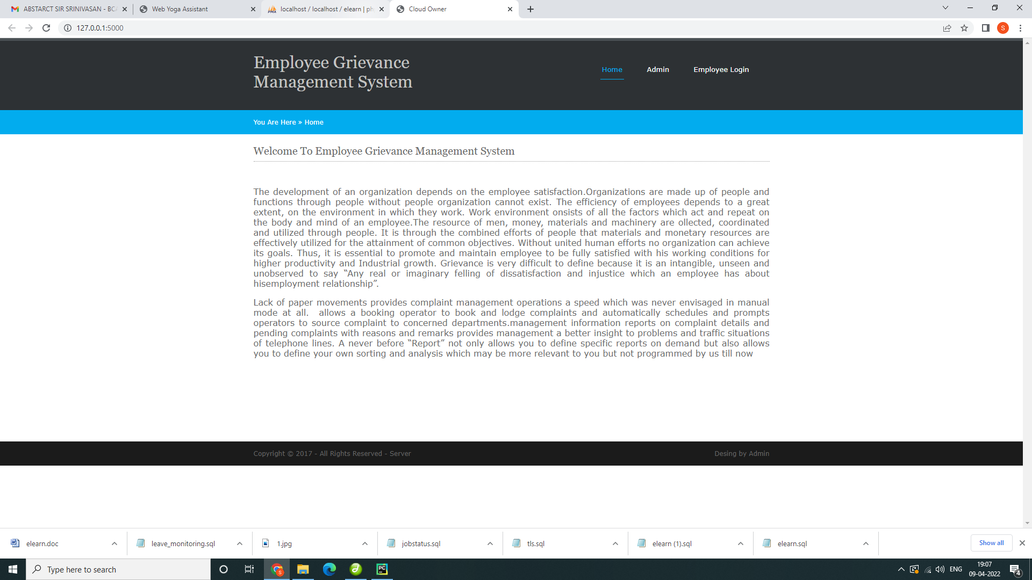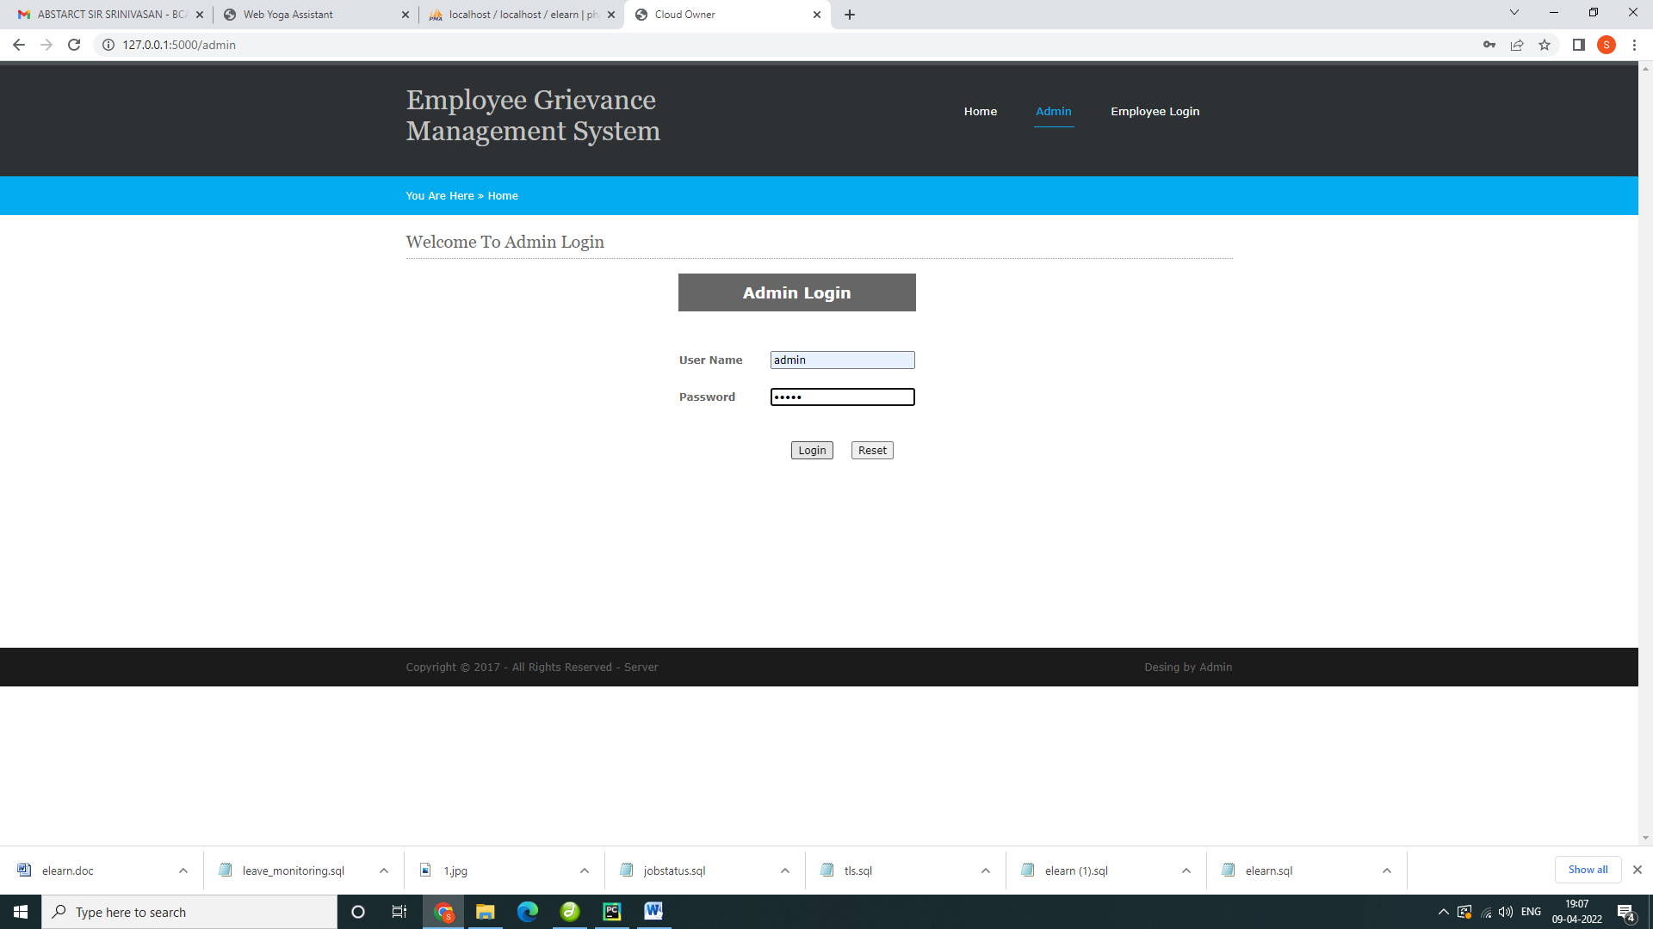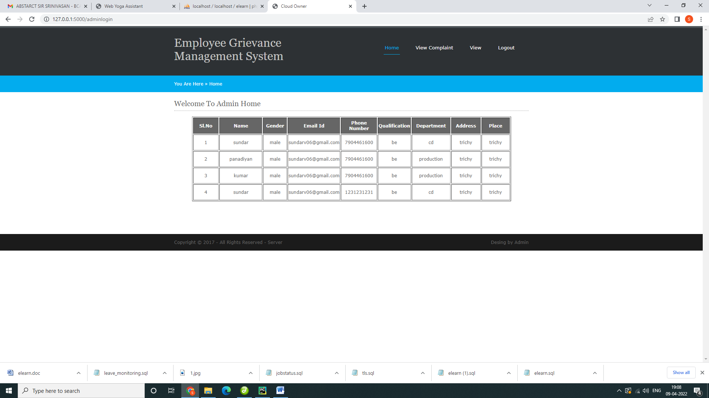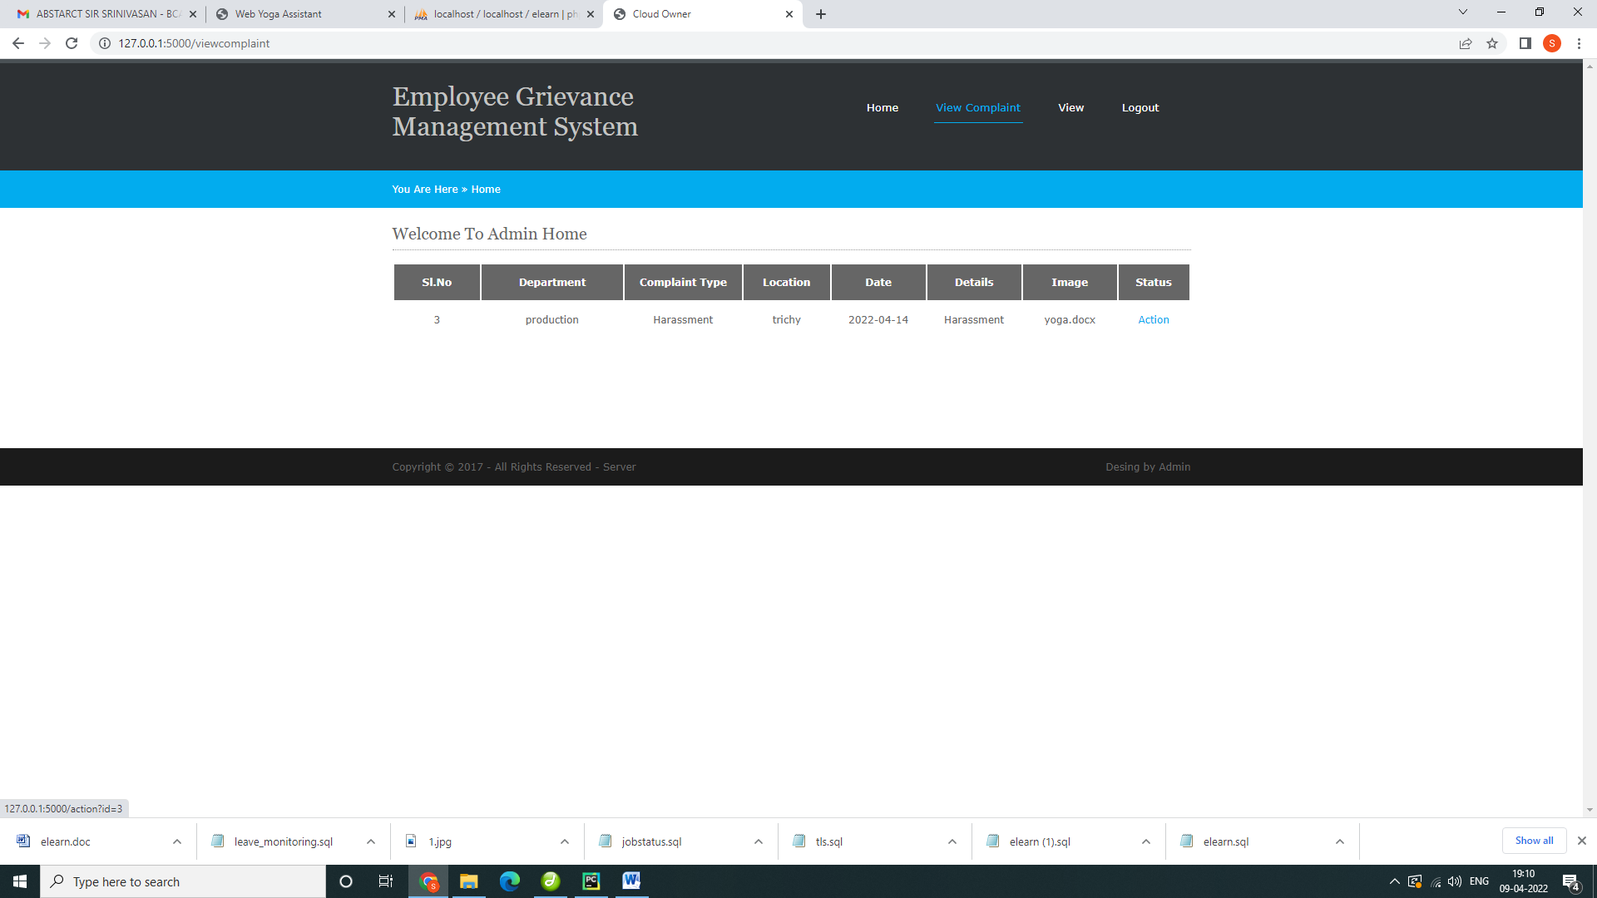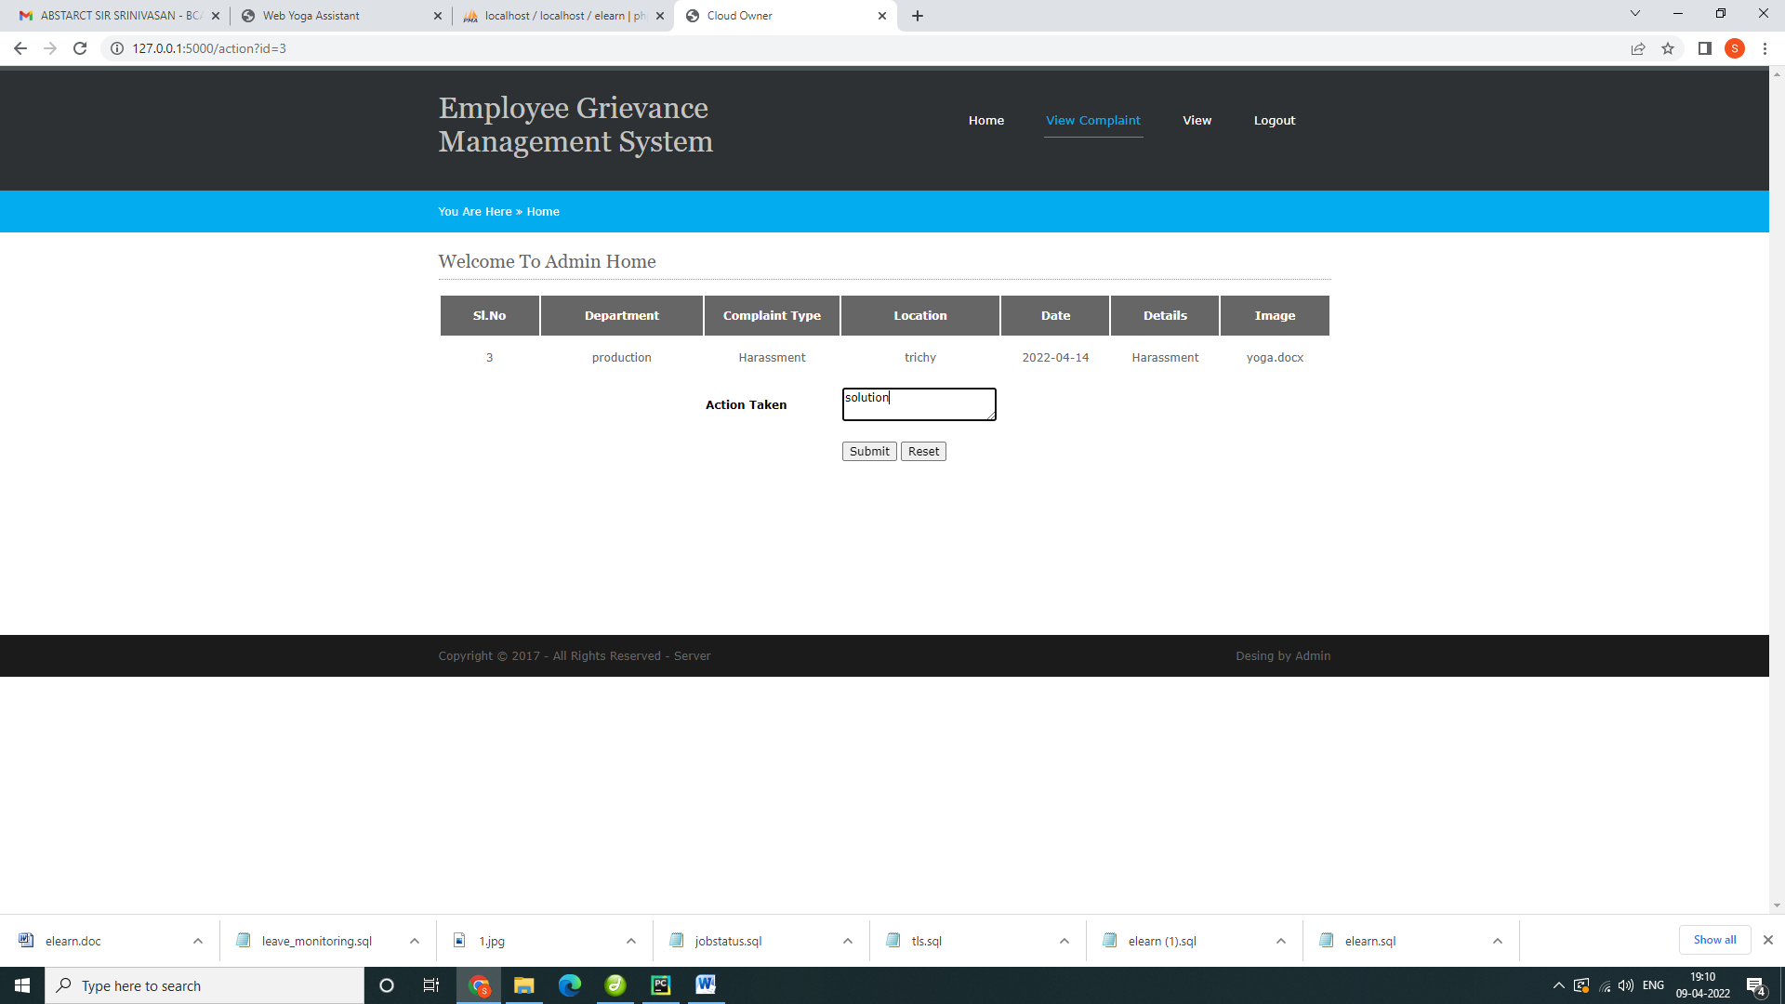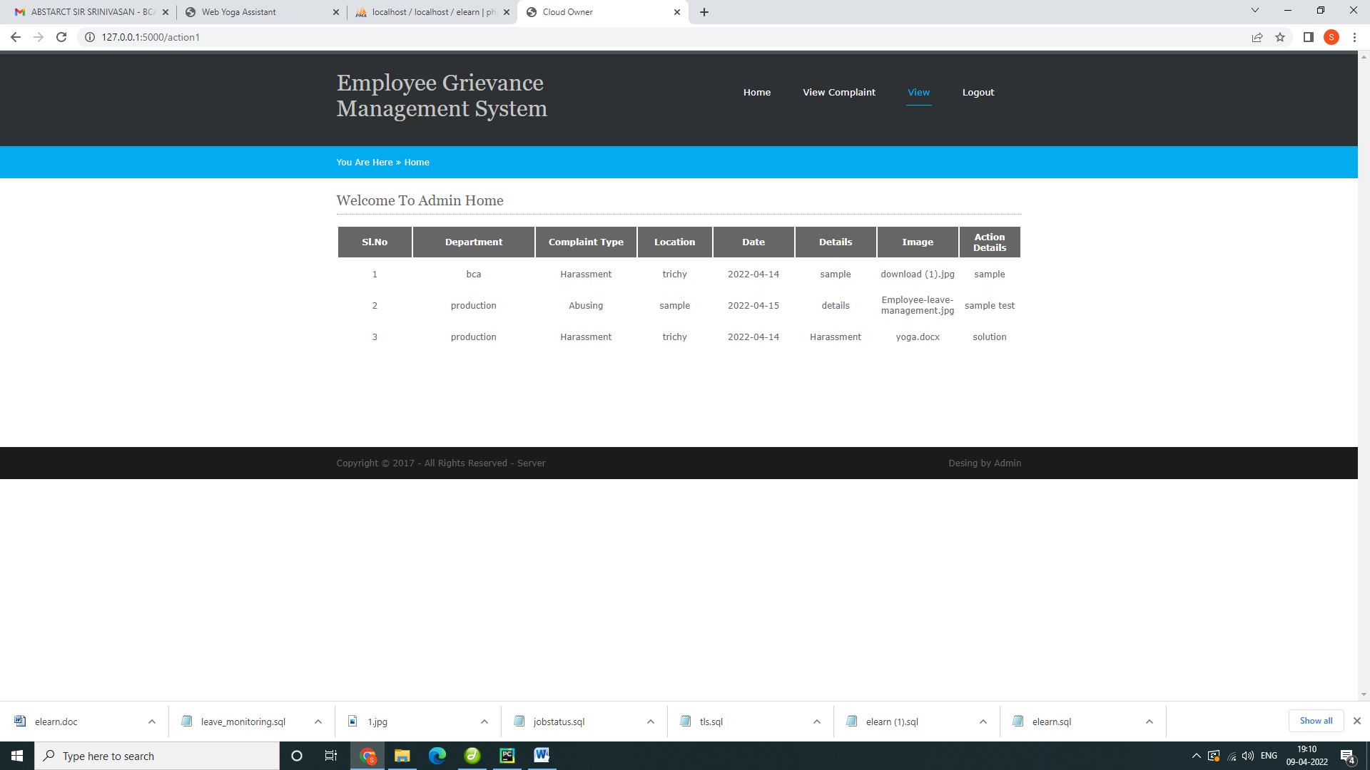

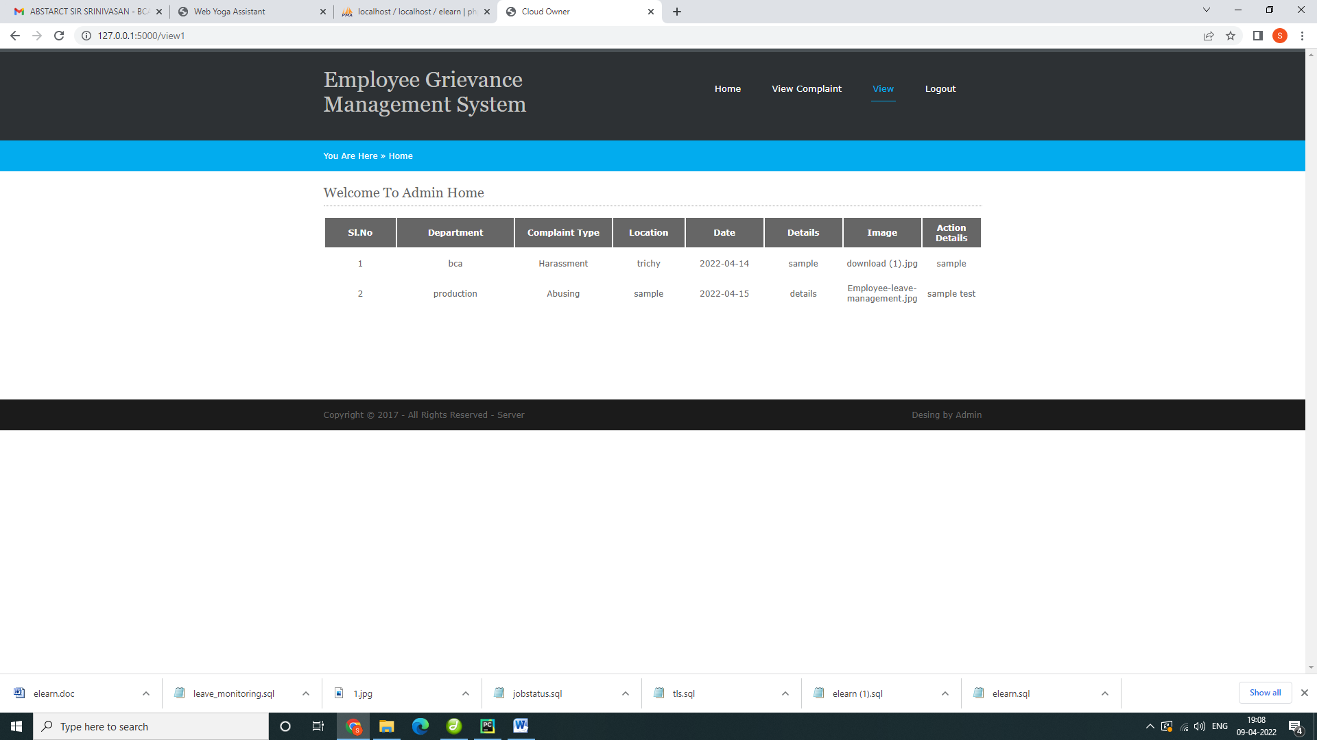

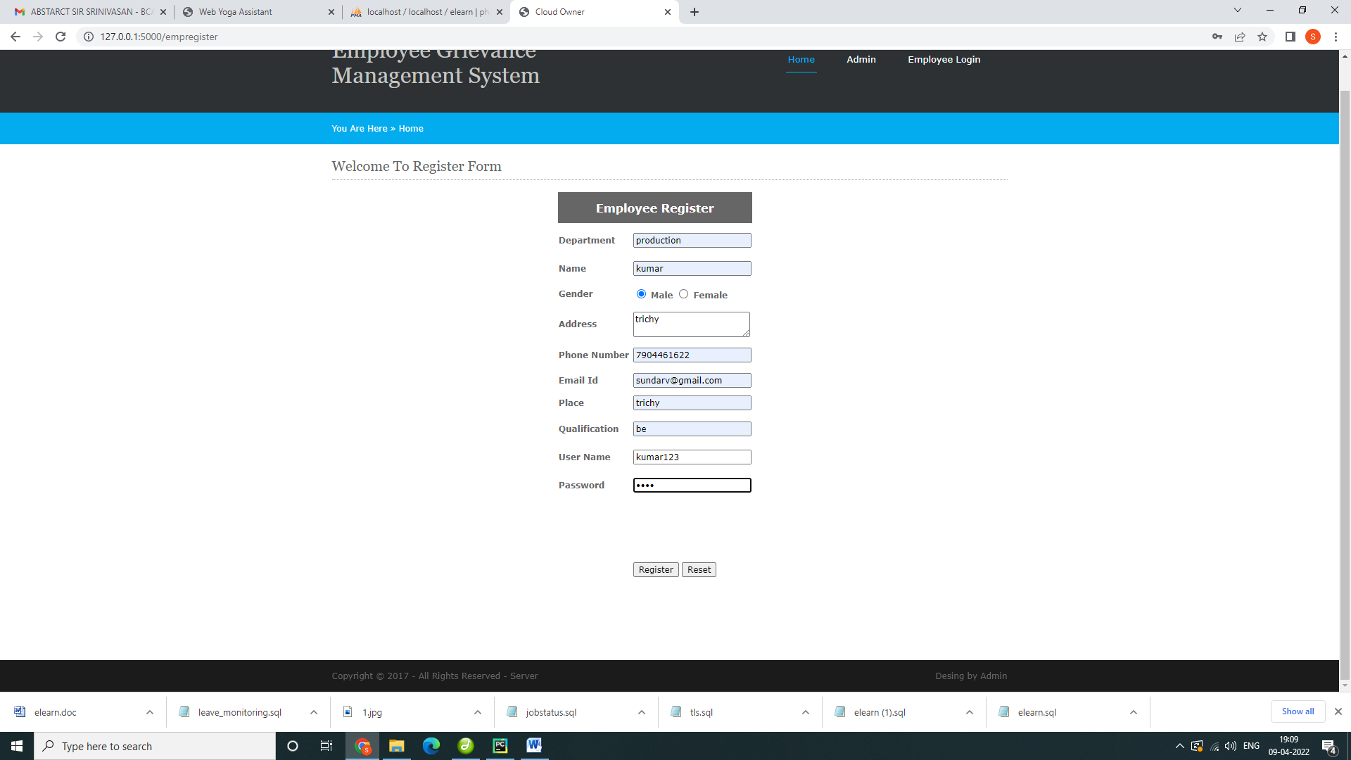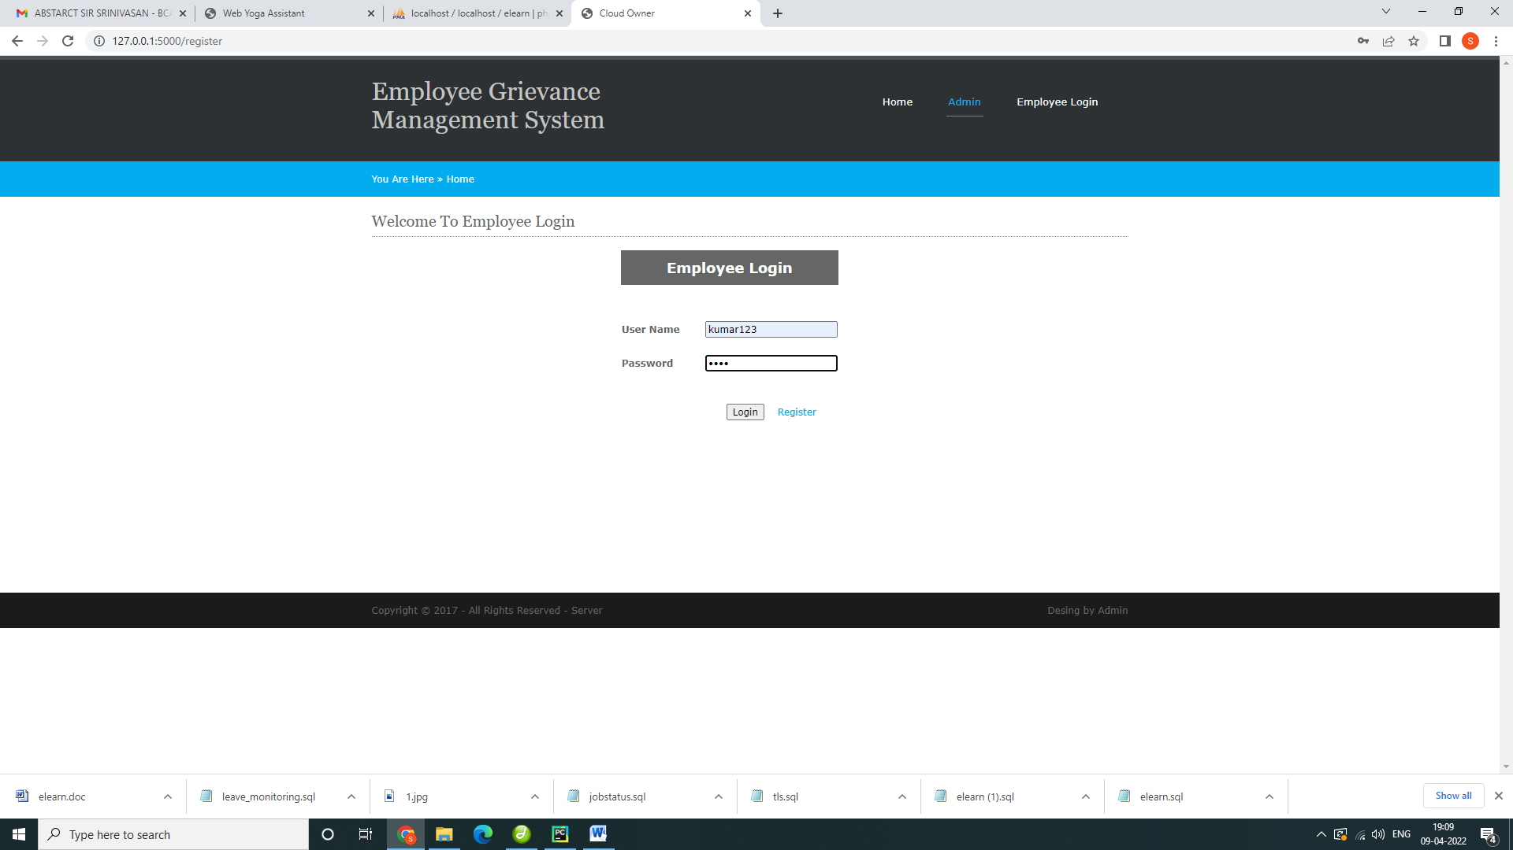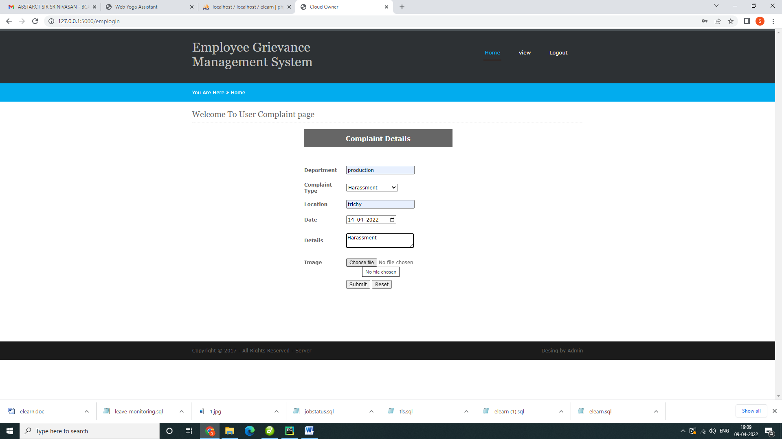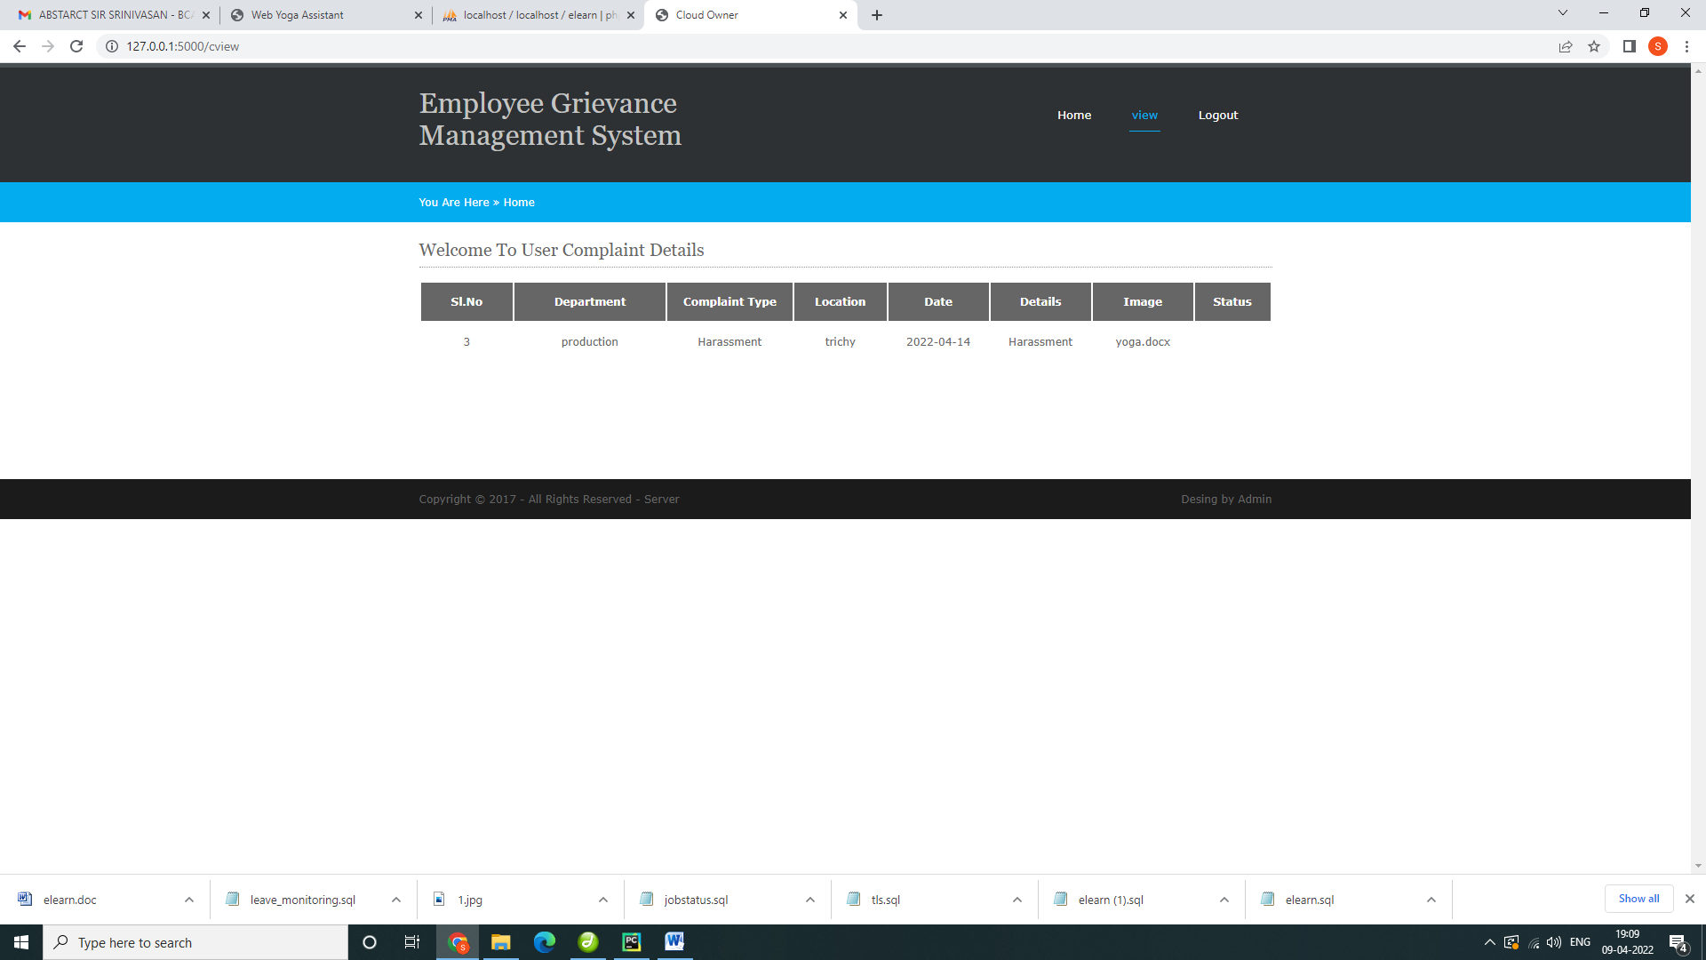

Python code:

**from** flask **import** Flask, render_template, flash, request, session,send_file  
**from** flask **import** render_template, redirect, url_for, request  
*#from wtforms import Form, TextField, TextAreaField, validators, StringField, SubmitField  
#from werkzeug.utils import secure_filename***import** datetime  
**import** mysql.connector  
**import** sys  
app = Flask(__name__)  
app.config[**'DEBUG'**]  
app.config[**'SECRET_KEY'**] = **'7d441f27d441f27567d441f2b6176a'**@app.route(**"/"**)  
**def** homepage():  
  
 **return** render_template(**'index.html'**)  
  
@app.route(**"/admin"**)  
**def** admin():  
  
 **return** render_template(**'adlog.html'**)  
  
  
@app.route(**"/login"**)  
**def** emp():  
 **return** render_template(**'login.html'**)  
@app.route(**"/adminhome"**)  
**def** adminhome():  
 conn = mysql.connector.connect(user=**'root'**, password=**''**, host=**'localhost'**, database=**'empcomp'**)  
 cur = conn.cursor()  
 cur.execute(**"SELECT * FROM employee "**)  
 data = cur.fetchall()  
  
  
 **return** render_template(**'adminhome.html'**, data=data)  
@app.route(**"/emphome"**)  
**def** emphome():  
 **return** render_template(**'emphome.html'**)  
@app.route(**"/empregister"**)  
**def** empregister():  
 **return** render_template(**'register.html'**)  
  
  
  
@app.route(**"/adminlogin"**, methods=[**'GET'**, **'POST'**])  
**def** adminlogin():  
 error = **None  
 if** request.method == **'POST'**:  
 **if** request.form[**'uname'**] == **'admin' or** request.form[**'password'**] == **'admin'**:  
  
 conn = mysql.connector.connect(user=**'root'**, password=**''**, host=**'localhost'**, database=**'empcomp'**)  
 *# cursor = conn.cursor()* cur = conn.cursor()  
 cur.execute(**"SELECT * FROM employee "**)  
 data = cur.fetchall()  
  
 **return** render_template(**'adminhome.html'**,data=data)  
  
 **else**:  
 **return** render_template(**'index.html'**, error=error)  
  
  
@app.route(**"/emplogin"**, methods=[**'GET'**, **'POST'**])  
**def** emplogin():  
 error = **None  
 if** request.method == **'POST'**:  
 username = request.form[**'uname'**]  
 password = request.form[**'password'**]  
 session[**'fname'**] = request.form[**'uname'**]  
  
 conn = mysql.connector.connect(user=**'root'**, password=**''**, host=**'localhost'**, database=**'empcomp'**)  
 cursor = conn.cursor()  
 cursor.execute(**"SELECT * from employee where uname='"** + username + **"' and password='"** + password + **"'"**)  
 data = cursor.fetchone()  
 **if** data **is None**:  
 alert = **'Username or Password is wrong'  
 return** render_template(**'goback.html'**, data=alert)  
 **else**:  
 print(data[0])  
 session[**'uid'**] = data[0]  
 conn = mysql.connector.connect(user=**'root'**, password=**''**, host=**'localhost'**, database=**'empcomp'**)  
 *# cursor = conn.cursor()* cur = conn.cursor()  
 cur.execute(**"SELECT * FROM employee where uname='"** + username + **"' and password='"** + password + **"'"**)  
 data = cur.fetchall()  
  
 **return** render_template(**'emphome.html'**, data=data)  
  
  
@app.route(**"/register"**, methods=[**'GET'**, **'POST'**])  
**def** register():  
 **if** request.method == **'POST'**:  
  
 name1 = request.form[**'name'**]  
 gender = request.form[**'gender'**]  
  
 email = request.form[**'email'**]  
  
 phone = request.form[**'phone'**]  
  
  
  
 address = request.form[**'address'**]  
 uname = request.form[**'uname'**]  
 password = request.form[**'password'**]  
 dept = request.form[**'dept'**]  
 qual = request.form[**'qual'**]  
 place = request.form[**'place'**]  
  
  
 conn = mysql.connector.connect(user=**'root'**, password=**''**, host=**'localhost'**, database=**'empcomp'**)  
 cursor = conn.cursor()  
 cursor.execute(  
 **"INSERT INTO employee VALUES ('','"** + name1 + **"','"** + gender + **"','"**+ email+**"','"**+phone+**"','"** + qual + **"','"** + dept + **"','"**+address+**"','"**+place+**"','"**+uname+**"','"**+password+**"')"**)  
 conn.commit()  
 conn.close()  
  
  
 **return** render_template(**'login.html'**)  
  
  
@app.route(**"/complaint"**, methods=[**'GET'**, **'POST'**])  
**def** complaint():  
 **if** request.method == **'POST'**:  
  
 dept = request.form[**'dept'**]  
 cctype = request.form[**'ctype'**]  
  
 location = request.form[**'location'**]  
  
 date = request.form[**'date'**]  
 uname= session[**'fname'**]  
  
  
  
 details = request.form[**'details'**]  
 file = request.files[**'file'**]  
 file.save(**"static/upload/"** + file.filename)  
  
  
 conn = mysql.connector.connect(user=**'root'**, password=**''**, host=**'localhost'**, database=**'empcomp'**)  
 cursor = conn.cursor()  
 cursor.execute(  
 **"INSERT INTO complaint VALUES ('','"** + uname + **"','"** + dept + **"','"**+ cctype+**"','"**+location+**"','"** + date + **"','"** + details + **"','"**+file.filename+**"','')"**)  
 conn.commit()  
 conn.close()  
  
  
 **return** render_template(**'emphome.html'**)  
  
@app.route(**"/cview"**)  
**def** cview():  
 uname = session[**'fname'**]  
 conn = mysql.connector.connect(user=**'root'**, password=**''**, host=**'localhost'**, database=**'empcomp'**)  
 *# cursor = conn.cursor()* cur = conn.cursor()  
 cur.execute(**"SELECT * FROM complaint where uname='"** + uname + **"' "**)  
 data = cur.fetchall()  
  
 **return** render_template(**'cview.html'**, data=data)  
@app.route(**"/viewcomplaint"**)  
**def** viewcomplaint():  
 uname = session[**'fname'**]  
 conn = mysql.connector.connect(user=**'root'**, password=**''**, host=**'localhost'**, database=**'empcomp'**)  
 *# cursor = conn.cursor()* cur = conn.cursor()  
 cur.execute(**"SELECT * FROM complaint where status=''"**)  
 data = cur.fetchall()  
  
 **return** render_template(**'viewcomplaint.html'**, data=data)  
@app.route(**"/action"**)  
**def** action():  
  
  
 *#categories=request.form['id']* id=request.args.get(**'id'**)  
  
 print(id)  
 conn = mysql.connector.connect(user=**'root'**, password=**''**, host=**'localhost'**, database=**'empcomp'**)  
 cursor = conn.cursor()  
 cursor.execute(**"select * from complaint where id='"**+id+**"'"**)  
 data = cursor.fetchall()  
 print(data)  
 **return** render_template(**"action.html"**, data=data)  
@app.route(**"/action1"**, methods=[**'GET'**, **'POST'**])  
**def** action1():  
 **if** request.method == **'POST'**:  
  
  
 *#categories=request.form['id']* id = request.form[**'id'**]  
 cctype = request.form[**'ataken'**]  
  
 print(id)  
 conn = mysql.connector.connect(user=**'root'**, password=**''**, host=**'localhost'**, database=**'empcomp'**)  
 cursor = conn.cursor()  
 cursor.execute(**"update complaint set status='"**+ cctype +**"' where id='"**+ id +**"'"**)  
 conn.commit()  
 conn.close()  
 conn1 = mysql.connector.connect(user=**'root'**, password=**''**, host=**'localhost'**, database=**'empcomp'**)  
  
 cursor1 = conn1.cursor()  
 cursor1.execute(**"select * from complaint "**)  
 data = cursor1.fetchall()  
 **return** render_template(**"view1.html"**, data=data)  
@app.route(**"/view1"**)  
**def** view1():  
  
  
 *#categories=request.form['id']* id=request.args.get(**'id'**)  
  
 print(id)  
 conn = mysql.connector.connect(user=**'root'**, password=**''**, host=**'localhost'**, database=**'empcomp'**)  
 cursor = conn.cursor()  
 cursor.execute(**"select * from complaint"**)  
 data = cursor.fetchall()  
 print(data)  
 **return** render_template(**"view1.html"**, data=data)  
**if** __name__ == **'__main__'**:  
 app.run(debug=**True**, use_reloader=**True**)

tables

# Database empcomp

## Table structure for table admin

|  |  |  |  |
| --- | --- | --- | --- |
| **Field** | **Type** | **Null** | **Default** |
| uname | varchar(50) | Yes | NULL |
| password | varchar(50) | Yes | NULL |

## Dumping data for table admin

|  |  |
| --- | --- |
| admin | admin |

## Table structure for table complaint

|  |  |  |  |
| --- | --- | --- | --- |
| **Field** | **Type** | **Null** | **Default** |
| ***id*** | int(50) | Yes | NULL |
| uname | varchar(50) | Yes | NULL |
| dept | varchar(50) | Yes | NULL |
| ctype | varchar(50) | Yes | NULL |
| location | varchar(50) | Yes | NULL |
| date | varchar(50) | Yes | NULL |
| details | varchar(50) | Yes | NULL |
| image | varchar(50) | Yes | NULL |
| status | varchar(50) | Yes | NULL |

## Dumping data for table complaint

|  |  |  |  |  |  |  |  |  |
| --- | --- | --- | --- | --- | --- | --- | --- | --- |
| 1 | pandiyan | bca | Harassment | trichy | 2022-04-14 | sample | download (1).jpg | sample |
| 2 | k222 | production | Abusing | sample | 2022-04-15 | details | Employee-leave-management.jpg | sample test |
| 3 | kumar123 | production | Harassment | trichy | 2022-04-14 | Harassment | yoga.docx | solution |

## Table structure for table employee

|  |  |  |  |
| --- | --- | --- | --- |
| **Field** | **Type** | **Null** | **Default** |
| ***id*** | int(50) | Yes | NULL |
| name | varchar(50) | Yes | NULL |
| gender | varchar(50) | Yes | NULL |
| email | varchar(50) | Yes | NULL |
| phone | varchar(50) | Yes | NULL |
| qual | varchar(50) | Yes | NULL |
| dept | varchar(50) | Yes | NULL |
| address | varchar(50) | Yes | NULL |
| place | varchar(50) | Yes | NULL |
| uname | varchar(50) | Yes | NULL |
| password | varchar(50) | Yes | NULL |

## Dumping data for table employee

|  |  |  |  |  |  |  |  |  |  |  |
| --- | --- | --- | --- | --- | --- | --- | --- | --- | --- | --- |
| 1 | sundar | male | sundarv06@gmail.com | 7904461600 | be | cd | trichy | trichy | 111 | 111 |
| 2 | panadiyan | male | sundarv06@gmail.com | 7904461600 | be | production | trichy | trichy | pandiyan | 123456 |
| 3 | kumar | male | sundarv06@gmail.com | 7904461600 | be | production | trichy | trichy | k222 | k222 |
| 4 | sundar | male | sundarv06@gmail.com | 1231231231 | be | cd | trichy | trichy | admin | 123 |
| 5 | kumar | male | sundarv@gmail.com | 7904461622 | be | production | trichy | trichy | kumar123 | k123 |